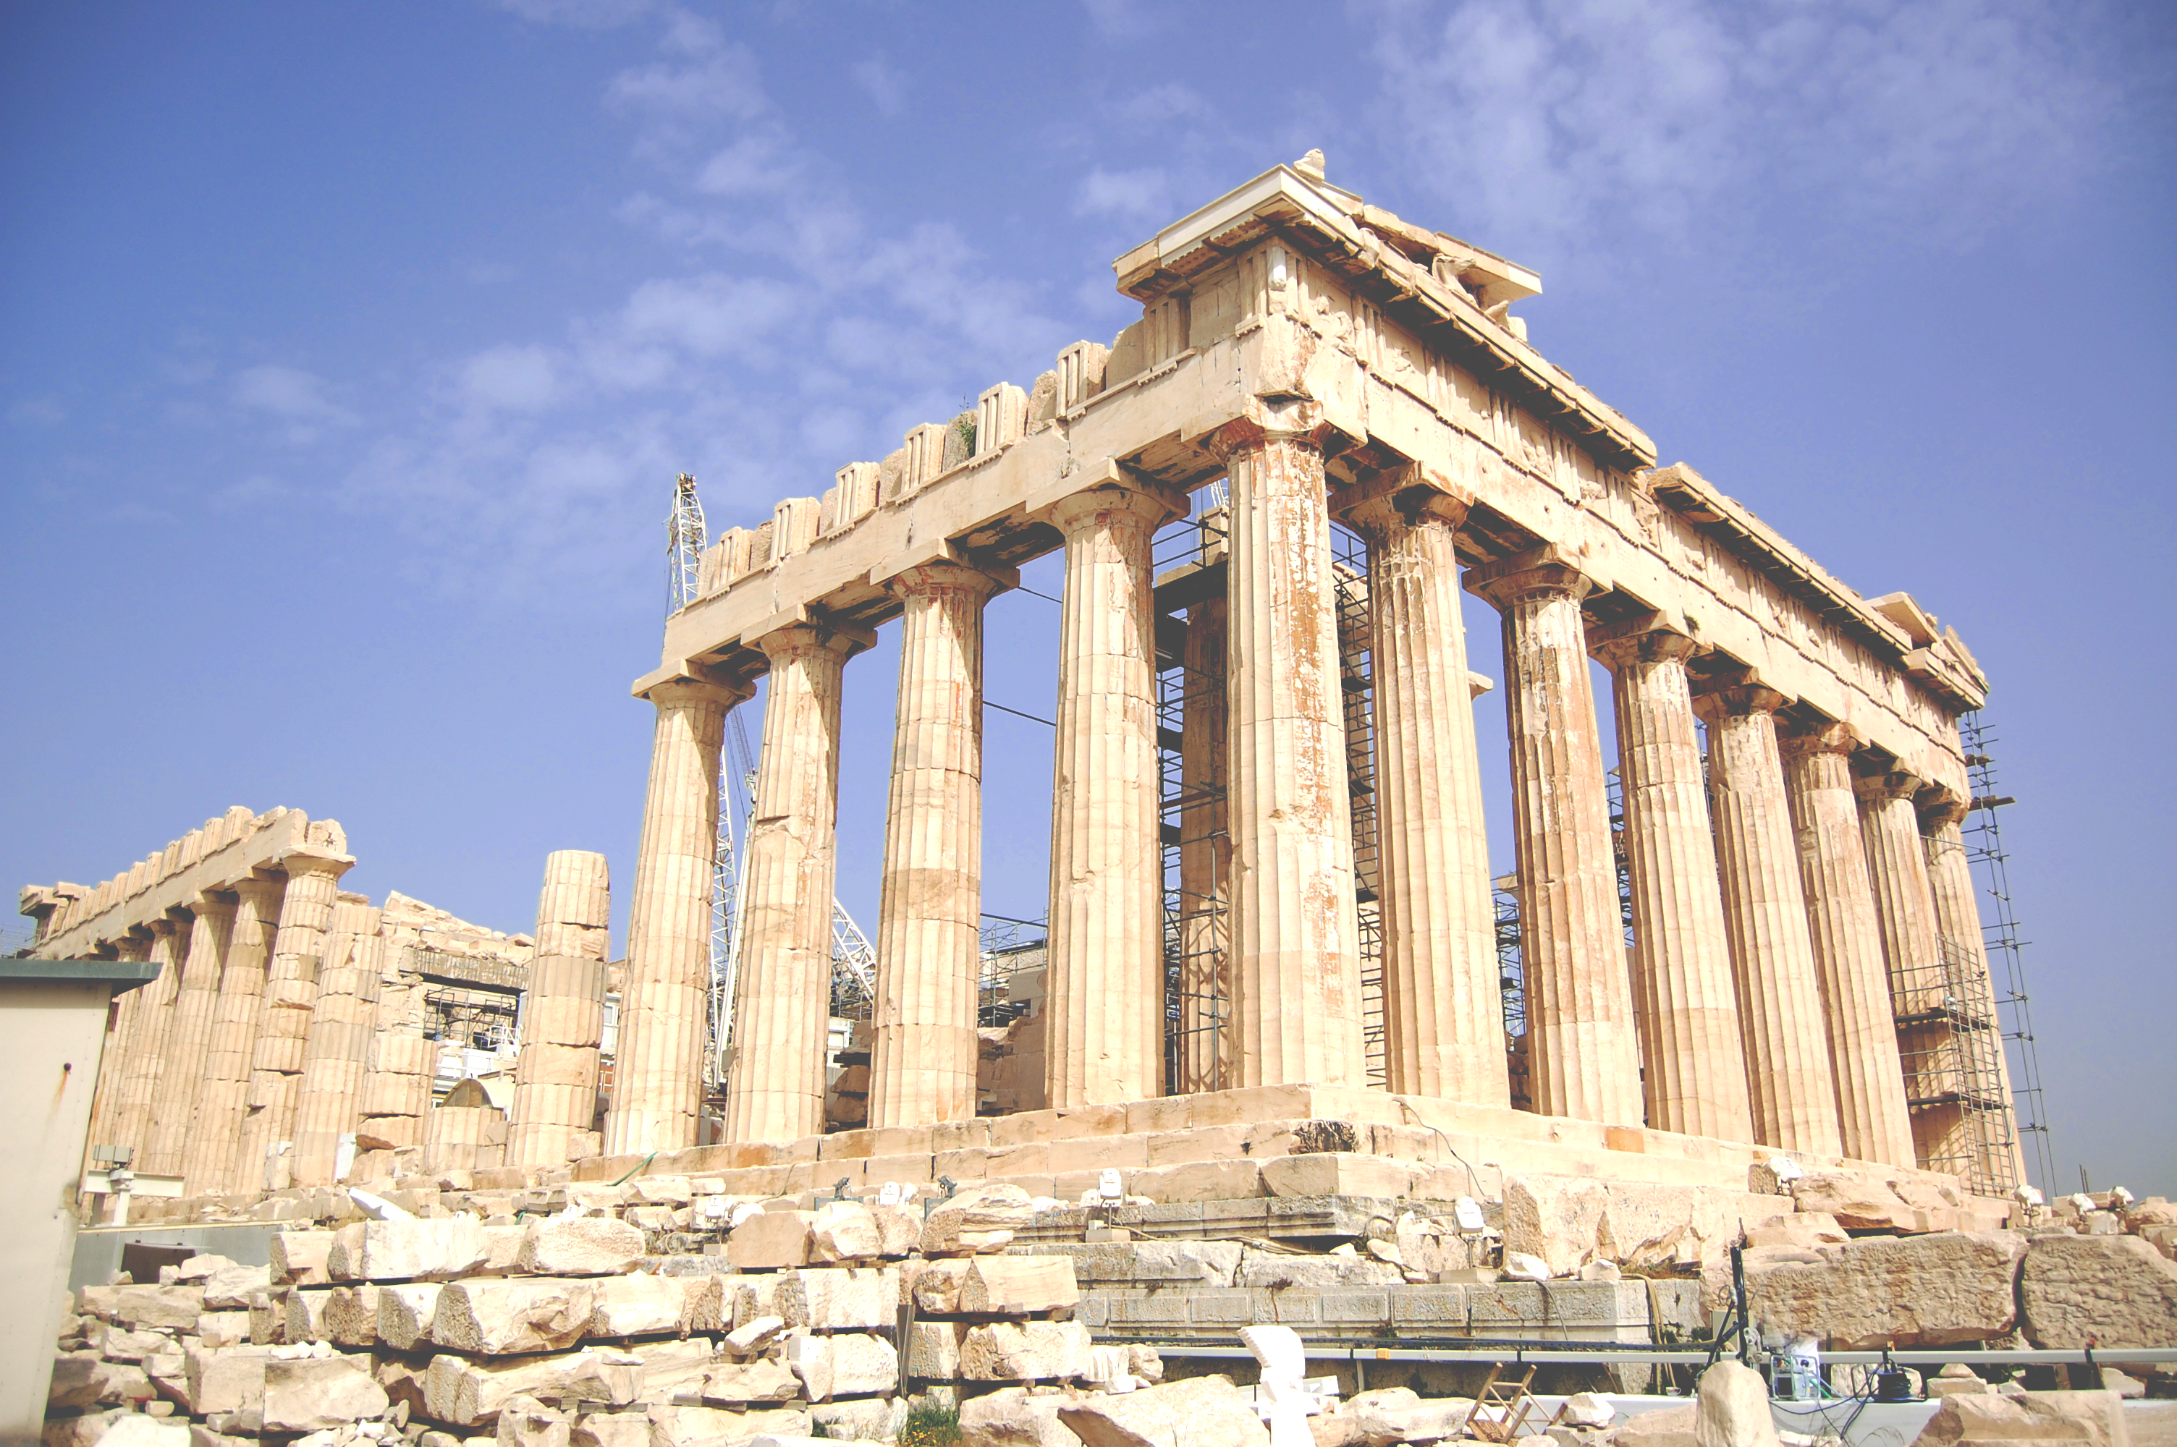
VCBC Sermon Notes|
Pastor Tom Cowan |May 5, 2013
Cities Series| 1 Corinthians 13
(pew Bible pg.1061)
The Church in the Worst
City In the World
Someone has suggested that if you were to add the Red Light district in Amsterdam, the sensuality of Las Vegas to the affluence of New York, you would end up with Corinth!
It was a great commercial centre; but it was a highly sexualised city. But in this sensual city, we find a church! It was a church with a lot of problems.
Here is the agenda for the Council meeting this evening:
- _____________________________________
- _____________________________________
- _____________________________________
- _____________________________________
- _____________________________________
- _____________________________________
- _____________________________________
- _____________________________________
- _____________________________________
How can you hope to disciple a new Christian in the atmosphere of this city?
- IT WILL TAKE A CHURCH THAT BELIEVES IN THE RADICAL POWER OF THE CROSS – NOTHING LESS WILL DO!
1 Corinthians 6:9-11 reminds Christians what Christ has done for them.
Grace is free but it is no cheap!
- IT WILL TAKE A CHURCH THAT BELIEVES IN THE RADICAL POWER OF THE SPIRIT – NOTHING LESS WILL DO!
How will new Christians sat clean and pure in this city?
Paul says ... ‘Do you not know that your body is the temple of the Holy Spirit? You are not your own; you were bought with a price.’
We need to understand 2 words for “temple”.
1. Hieron -
2. Naos -
Morality is rooted in identity; personal ethics are rooted in integrity.
- IT WILL TAKE A CHURCH THAT BELIEVES IN THE RADICAL STRENGTH OF THE COMMUNITY – NOTHING LESS WILL DO!
- It challenges the spirit of individualism by calling us into community.
- It challenges the spirit of consumerism, by calling us into teamwork.
- It challenges the spirit of licence by calling us to true freedom.
- It challenges the spirit of selfish eroticism by calling us to a new law of love. (1st Corinthians 13)
REFLECTION AND DISCUSSION:

- What do you find tempting about the spirit of the city in Vancouver? How do you deal with that temptation?
- Do you really grasp the radical power of the cross in your life? What would help you to do that?
- Have you ever thought about the phrase that ... your body is the temple of the Holy Spirit? Go back over what Pastor Tom taught about naos.
- Do you believe in the radical strength of community at VCBC? What does this mean? What would make it stronger for you?

